status information
Security classification: | Confidential  Restricted  Internal  Unclassified |  | Status: |  | Final
Current version number: | V1.0 | Date of first issue: |  |  | 28 mars 2016
Prepared by: | CGI |  |  | Date: | 13/04/2016
Verified by: | Architects and experts DSIG |  |  | Date:
Approved by: | Grinsztajn Julien |  |  | Date:
Copyright notice
This document may not be reproduced (even partially) or communicated to third parties without the written authorization of the company’s General Management.
DISTRIBUTION LIST
Name | Address | I/A | Name | Address | I/A
Departments Architecture, Production and Telecom & Security CSPI and operators - Reviewers CVT |  | A
(I = for information, A = for action)
DOCUMENT CHANGE RECORD
Version | Date | Description | Affected sections
1.0 | 13/04/2016 | ASD initialization | Original version
2.0 | 05/05/2016 | Relecture Transverse
Table of Contents

1 Application Solution Architecture Overview 4
1.1 Application Solution Design Goals 4
1.2 Application Solution Design Constraints 4
1.2.1 Business Constraints 4
1.2.2 Service Constraints 4
1.2.3 technical constraints: 6
1.3 Compliance to Policies & Standards 7
1.4 Future Contingencies 7
2 Requirements Summary 8
2.1 Functional/Information Requirements 8
2.2 Operational Requirements 8
2.3 Security Requirements 8
3 Design of the application 9
3.1 Functional Architecture 9
3.1.1 Description of the architecture 9
3.1.2 Functional Flows 9
3.1.3 on other Functions 11
3.1.4 Future Evolutions 11
3.2 Information Architecture 11
3.2.1 Conceptual Data Model 11
3.2.2 Logical Data Model 11
3.2.3 Data Formatting & Processing 11
3.2.4 Future Evolutions 11
3.3 Application Architecture 12
3.3.1 Application Architecture 12
3.4 Environments 13
3.4.1 Description of the plateforms 13
3.4.2 Sizing 14
3.4.3 Clearances 15
3.4.4 Deployment Architecture 15
3.5 Security Controls Design 17
3.5.1 run management 17
Reporting 17
Purge 17
Annex 18
3.6 References 18
3.7 Glossary 18
3.8 Appendices 20

Application Solution Architecture Overview

Application Solution Design Goals

AD-VEGA is a project that allows all of the GDF-Suez users to access the group’s applications. For that purpose, a windows accounts directory was established as an Active Directory (AD) named VEGA.
The “Exchange Pole” is involved in the procurement process of this AD by transmitting the stored user accounts in the office AD, to the identity management and users access application of SI GDF SUEZ (GAIA).
The goal of these exchanges is offering an automated solution to supply VEGA directory by the active directories (using GAIA application).

Application Solution Design Constraints

Business Constraints
The main business constraints are:
- Security and confidentiality of data.
- Data quality.
- Coherence of data regarding AD’s sources that supply ADVEGA.

Service Constraints

- Data exchanges take place on a scheduled, daily basis.
- Daily updating of GAIA users accounts repository of the group.
- DIMA (Maximum Unavailability Time allowable) = ADVEGA requests 2 worked days.
- ADVEGA application is considered of criticality level 2.

- GENERAL SERVICE PERIODS:
Environment | Opening time for users | sensitive time system | Application sensitive period | call period system | application call period | Criticality Level | operating type
Production | Standard 2 | 20h45 – 21h45 (every day) | 20h45 – 21h45 (every day) | Normal  (5 worked days from 08h00 – 18h00) | Normal  (5 worked days from 08h00 – 18h00) | C2 | OS MANAGE +  (except Oracle database : FULL MANAGE)
PreProduction | Standard 2 | 20h45 – 21h45 (every day) | 20h45 – 21h45 (every day) | Normal  (5 worked days from 08h00 – 18h00) | Normal  (5 worked days from 08h00 – 18h00) | C2 | OS MANAGE +  (except Oracle database : FULL MANAGE)
Development/ Integration | Standard 2 | N/A | N/A | Normal  (5 worked days from 08h00 – 18h00) | Normal  (5 worked days from 08h00 – 18h00) | N/A | OS MANAGE +  (except Oracle database : FULL MANAGE)

- LEVEL AND QUALITY OF SERVICE INFORMATION:
Environment | Availability | Information integrity | Protection and confidentiality of information | traceability | rescue | PDMA | DIMA
Production | level 1 | l4 | P1 | T1 | S2 | 24H | 24H
preproduction | 96% level 1 | l4 | P1 | T1 | S2 | 24H | 24H
Integration/ Development | 96% level 1 | l4 | P1 | T1 | S1 | N/A | N/A

- Availability:
The availability expected from the application is the standard level.

- Information integrity:
- Securing transferred files
- Ensuring integrity of the necessary source files with the signature of the sender.

- Protection and confidentiality of information:
The data are not confidential.

- traceability:
The traceability of exchanges is performed via the IHM INES-OSS included in the INES base.

- relief supplies:
In case of unavailability of the PROD environment, the PREPROD environment will be used according to DIMA deadlines.

technical constraints:
Communication:
- FTP flow between the INES platform and GAIA.
- SFTP flow between the INES platform and the Ad CORP
- SFTP flow between the INES platform and the Ad CORPO
- SFTP flow between the INES platform and the Ad TES
- SFTP flow between the INES platform and the Ad UNIT
- SFTP flow between the INES platform and the Ad SDMN01
The project will use dedicated application components NR INES in the infrastructure INES broken down as follows:

ENVIRONMENT | INGREDIENTS
DEVELOPMENT | - The webMethods Integration Server v9.9  - The webMethods Broker Server v9.9  - Database of monitoring  - Database of traces  - Data Base Business  - Supervision OSS
INTEGRATION | - The webMethods Integration Server v9.9  - The webMethods Broker Server v9.9  - Database of monitoring  - Database of traces  - Data Base Business  - Supervision OSS
PRE-PRODUCTION | - The webMethods Integration Server v9.9  - The webMethods Broker Server v9.9  - Database of monitoring  - Database of traces  - Data Base Business  - Supervision OSS
PRODUCTION | - The webMethods Integration Server v9.9  - The webMethods Broker Server v9.9  - Database of monitoring  - Database of traces  - Data Base Business  - Supervision OSS

Compliance to Policies & Standards

The implementation of the solution is based on the application of several rules and standards.
RULE OR STANDARD | REFERENCE DOCUMENT
development of standards and packaging INES | DSIG-INES-MAN-NormeDeveloppementEtPackaging-05-032-v4.4

Future Contingencies
Not applicable.

Requirements Summary

Functional/Information Requirements

Functional / Information Requirement | Description
Expose services for sending files | Transmission and recovery of files.

Operational Requirements

Operational Requirement | Description
The files should be in CSV format and UTF-8 WITH BOM encoding | The files transferred must adapt to this format.

Security Requirements
Needs related to security constraints are described in the document ISP.

Security Requirement | Description
Securing exchanges | All exchanges must be secured  (Secure protocol FTPS / SFTP)

Design of the application
This section should refine and deepen the information previously indicated in the Business Case when necessary.

Functional Architecture

Description of the architecture

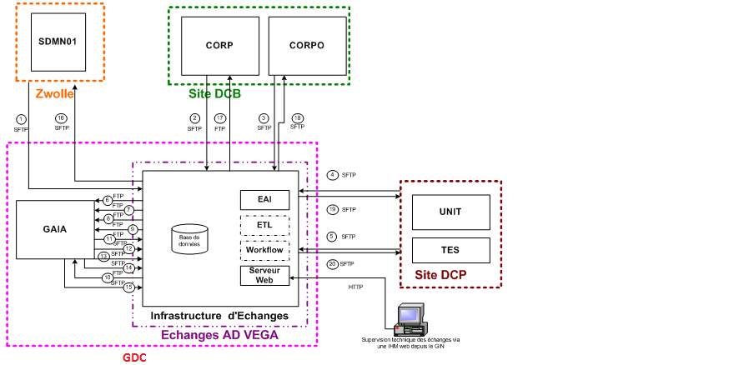

Functional Flows
A description of functional flows should be completed in the following table:
Functional flows | Source | Target | Description
A1 | AD SDMN01 | INES-EXCHANGES | File deposit
A2 | AD CORP | INES-EXCHANGES | File deposit
A3 | AD CORPO | INES-EXCHANGES | File deposit
A4 | AD UNIT | INES-EXCHANGES | File deposit
A5 | AD TES | INES-EXCHANGES | File deposit
A11,A12,A13,A14,A15 | GAIA | INES-EXCHANGES | File recovery
A6-A7-A8-A9-A10 | INES-EXCHANGES | GAIA | Transmission of file to the target application
A16 | AD SDMN01 | INES-EXCHANGES | File recovery
A17 | AD CORP | INES-EXCHANGES | File recovery
A18 | AD CORPO | INES-EXCHANGES | File recovery
A19 | AD UNIT | INES-EXCHANGES | File recovery
A20 | AD TES | INES-EXCHANGES | File recovery

Cinematic of exchanges
- Data file:

cinematic | Technical Reference Flow
Disposition of the data file by the AD | {A1,A5}
Transmission of the data file to GAIA | {A6,A10}
Transmission of the rejection quality file to GAIA (If the file has been generated from the data file control) | {A6,A10}
Retrieval of the rejection quality file put at the disposal of AD on INES server (If the file has been generated from the data file control) | {A16,A20}

- Rejection coherence file:

cinematic | Technical Reference Flow
Retrieval of the rejection coherence file from GAIA server | {A11,A15}
Retrieval of the rejection coherence file put at the disposal of AD on INES server | {A16,A20}

Mapping of flux:
Production flow matrix: | Flow Matrix Pre Production:
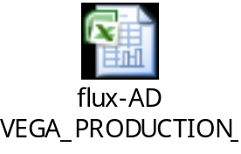 | 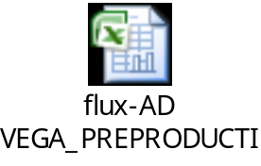
Flow Matrix Integ-rec: | Cartographie AdVega :
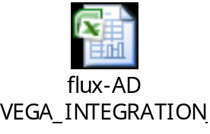 | 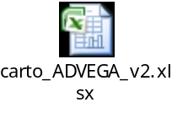

on other Functions
Not applicable.

Future Evolutions

Information Architecture

Conceptual Data Model
Cf. detailed functional specifications of ADVEGA Project.

Logical Data Model
Cf. detailed functional specifications of ADVEGA Project.

Data Formatting & Processing

Formatting
Cf. detailed functional specifications of ADVEGA Project.

Processing
Cf. detailed functional specifications of ADVEGA Project.

Future Evolutions
Not applicable.

Application Architecture

Application Architecture

As Is Application Architecture
The partner applications and active directories of ADVEGA are described in the following table:
Application | Description
GAIA | Infrastructure and organization services used to manage the Identities And Control the access to the Information system of the GDF SUEZ Employees: salaried or contractual of the group and certain extern people (Providers, Interim or partners).
SDMN01 | Active Directory du SI GDF SUEZ
TES | Active Directory du SI GDF SUEZ
CORP | Active Directory du SI GDF SUEZ
UNIT | Active Directory du SI GDF SUEZ
CORPO | Active Directory du SI GDF SUEZ

To Be Application Architecture

Using crossVista as deployment tool:
Following the rise of webMethods version using the Deployment Tool CrossVista be generalized. The current deployment process-based tool "Deployer" will be impacted.

Using secure protocols
Using the FTP protocol will be replaced by the use of secure protocols FTPS/SFTP.

Application Flows / Interface
This table describes the application flows and interface with other applications:
From Application | To Application | Description | Frequency
AD CORP | INES-EXCHANGES | File deposit | Every 5 minutes, between 20h and 21h
AD TES | INES-EXCHANGES | File deposit | Every 5 minutes, between 20h and 21h
AD UNIT | INES-EXCHANGES | File deposit | Every 5 minutes, between 20h and 21h
AD SDMN01 | INES-EXCHANGES | File deposit | Every 5 minutes, between 20h and 21h
AD CORPO | INES-EXCHANGES | File deposit | Every 5 minutes, between 20h and 21h
GAIA | INES-EXCHANGES | File recovery | Every 5 minutes, between 6h and 7h
INES-EXCHANGES | GAIA | Transmission of file to the target application

Impacts on other applications
Not applicable.

Future Evolutions
Not applicable.

Environments

Description of the plateforms
The environments available in the project are:
Name | Short Name | Description
Development | DEV | Environmental development and unit testing. It is dedicated to MOE teams.
Recipe | REC | Recipe environment MOA (TISI, business teams)
Pre-Production | PPRD | Pre-production environment; the only one with a similar infrastructure to that of production.  It can:  • Make the production start rehearsals in the closest possible conditions  • perform load testing and performance
Production | PRD | Environment of production.

Sizing

Environment | Synchronous | Asynchronous
Development | 1 (IS Business) | 1 IS Business
Recipe | 1 (IS Business) | 1 IS Business
Pre-Production | 1 (IS Business) | 1 IS Business
Production | 1 (IS Business) | 1 IS

Clearances
Tools/ENV | DEV/FOR/REC | PPROD | PROD
webMethods Administration Console | Accessible to development teams with either:  - The username / pwd default administrator  - Specific IDs created for each user | Accessible only to the EIMS operator | Accessible only to the EIMS operator
My WebMetods Console Server | Access to achievement and revenue teams with username / pwd | Accessible to the operator, the application and conduct the MCO team with username / pwd specific | Accessible to the operator, the application and conduct the MCO team with username / pwd specific
management console OSS | Accessible with username / pwd single for all users | Accessible with username / pwd single for all users | Accessible to all users who have the role GAIA necessary to access it (access via GAIA)
File System | Accessible teams to realization with a username / pwd dedicated to each application.  Note that teams MOE do not have access to the entire File system, some files and directories require root privileges to read / change (exemple / etc) | Accessible only to the EIMS operator | Accessible only to the REIMS operator

Deployment Architecture

Deployment Overview
The solution used for deployment is CrossVista.
The CrossVista Team Server is a solution supplied by one of Software AG's partner publishers.
CrossVista makes it possible to produce a release / deliverable (export) and also offers the possibility of deployment in a different environment.
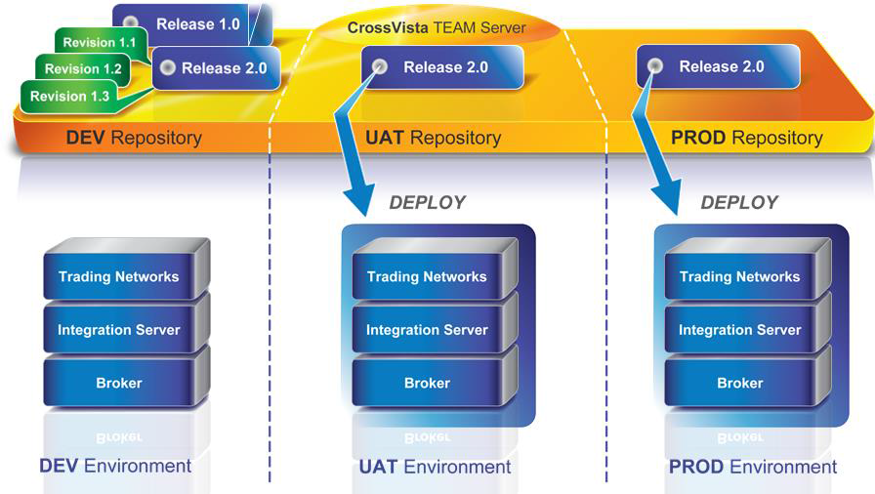

Description of deployment nodes
Properties | Values
Java home directory | /softs/java/jdk-7.1.0.15
Java min memory | 1024M
Java max memory | 1024M
Version | 9.6

Cf. CrossVista User Manual

Security Controls Design

run management

run management  type | Description
Supervision OSS | Supervision of trade is provided by the tool INES OSS base. This tool:  • Check the flow (date of treatment, duration of treatment, treatment status, the error message on failure)  • Find a stream by filtering on a list of criteria (called functional keys)  • Replay asynchronous flow in check
Reporting | after data replication in the replication database, a report describing the functional errors exchanges is sent daily to the profession
Logs /traces | The level of logging enabled on IS Metier is the default level: INFO (level 4).  Possible log levels are:  1. Fatal  2. Error  3. Warn  4. Info  5. Debug  6. Trace  The logs are available via:  • webMethods Administration Console at the section Logs / Server  • the file 'server.log' which is in the ... / IntegrationServer / logs /
archiving | The archiving policy is specific to each stream. For the archiving policy of a particular stream, refer to the document detailed functional specifications of the exchange in question.
replay | The replay policy is specific to each stream. To access the replay policy of a particular stream, refer to the document detailed functional specifications of the exchange in question.
Purge | The purge policy is specific to each stream. For a purge policy for a particular stream, refer to the document detailed functional specifications of the exchange in question.

Annex

References
Sans Objet.

Glossary
DSIG | Information Group Systems
+ DASL | Delegation of Architecture and Solutions
+ DI | IT delegation
| + Pôle Architecture | Architecture pole
| + Pôle Commercialisateur | Promoter pole
| + Pôle Telecom | Telecom pole
| + Pôle Rapsodie | Rapsodie pole
DGI | Direction of Major Infrastructures
+ CSI | Computing service center
| + DIC | Engineering and driving Department
| + DIC+ECA | Team of applications driving
| + DIC+EII | Engineering and Infrastructure Team
| + Pôle Tertiaire | Tertiary pole
| + …
DR | Research direction
+ DETI | Department of Economics and Information Processing
| + SII | IT Infrastructure Service
| + SIG | Internet Groupware
| + SIM | Computer Business Service
DS | Strategy Direction
Dircom | Communication Direction
DAR | Direction of Audit and Risk
DEP | Direction of Exploration and Production
GRT | Subsidiary Gas of France Transport Network
GRD | Direction Gas of France Distribution Network
EGD | Direction EDF Gaz of France Distribution
DRE | Delegation to the regulation and the economy
MPS | Permanent Security Mission
Dirco | Commercial Direction
DM | Delegation of Marketing
DCG | Direction Control of Management
DFC | Direction of Financing and Accounting
DIA | Direction of Investments and Acquisitions
DJ | Juridical Direction
DPRS | Staff and Social Affairs Direction
3D | Sustainable Development Department
DOMC | Delegation and Organization of Costs Control
DAG | Direction of groups sales
DRC | Delegation of group resources
DIM | Delegation of Real Estate
DIT | Direction of computing Network
EXS | Exploitation of servers
EXM | Exploitation of means
EXC | Exploitation of centers
MEP | Department into production
AEI | Agency of IT Operations (EDF)
BRIQUE | Coherent functional set of data or of applicative functions
CNIL | National commission of computing and freedom
CSA | Corresponding Servers and Applications (EXS)
DEX | Operating folder
DIMA | Maximum Unavailability Time allowable
DMZ | demilitarized zone
GFA | Closed Subscriber Group
GIN | Gas of France Interconnection
IHM | Human Machine Interface
LDAP | Lightweight Directory Access Protocol
MCO | Maintenance in working condition
MOA | Business Analyst
MOE | Mastery of work
PCS | Service Continuity Plan
PDMA | Maximum Allowable Loss of Data
PKI | Public Key Infrastructure
POA | Operational Application Driver
POP | Operational Project Driver
PQE | Operation Quality Plan
PSI | IT backup plan
PTE | Technical Operating Procedure
PTI | Technical Installation Procedure
PTM | Technical Migration procedure
PTR | Technical recovery procedure
RIN | National Internal Network
SGBD | Database Management System

Appendices
not applicable

